Template Method
(Behavioural)

Template method defines the steps to execute an algorithm and it can provide default implementation that might be common for all or some of the subclasses. Let’s understand this pattern with an example, suppose we want to provide an algorithm to build a house. The steps need to be performed to build a house are - building foundation, building pillars, building walls and windows. The important point is that the we can’t change the order of execution because we can’t build windows before building the foundation. So in this case we can create a template method that will use different methods to build the house. Now building the foundation for a house is same for all type of houses, whether its a wooden house or a glass house. So we can provide base implementation for this, if subclasses want to override this method, they can but mostly it’s common for all the types of houses. To make sure that subclasses don’t override the template method, we should make it final.

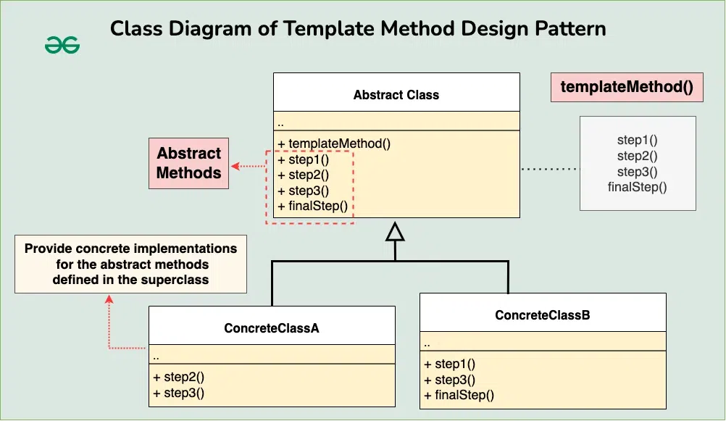

Step 1
public abstract class HouseTemplate {

//template method, final so subclasses can't override
public final void buildHouse(){
buildFoundation();
buildPillars();
buildWalls();
buildWindows();
System.out.println("House is built.");
}

//default implementation
private void buildWindows() {
System.out.println("Building Glass Windows");
}

//methods to be implemented by subclasses
public abstract void buildWalls();
public abstract void buildPillars();

private void buildFoundation() {
System.out.println("Building foundation with cement,iron rods and sand");
}
}

Step 2
public class WoodenHouse extends HouseTemplate {

@Override
public void buildWalls() {
System.out.println("Building Wooden Walls");
}

@Override
public void buildPillars() {
System.out.println("Building Pillars with Wood coating");
}

}
public class GlassHouse extends HouseTemplate {

@Override
public void buildWalls() {
System.out.println("Building Glass Walls");
}

@Override
public void buildPillars() {
System.out.println("Building Pillars with glass coating");
}

}

Step 3
public class HousingClient {

public static void main(String[] args) {

HouseTemplate houseType = new WoodenHouse();

//using template method
houseType.buildHouse();
System.out.println("************");

houseType = new GlassHouse();

houseType.buildHouse();
}

}

Step 4 (output)
Building foundation with cement,iron rods and sand
Building Pillars with Wood coating
Building Wooden Walls
Building Glass Windows
House is built.
************
Building foundation with cement,iron rods and sand
Building Pillars with glass coating
Building Glass Walls
Building Glass Windows
House is built.
Template Method Design Pattern Important Points
- Template method should consists of certain steps whose order is fixed and for some of the methods, implementation differs from base class to subclass. Template method should be final.
- Most of the times, subclasses calls methods from super class but in template pattern, superclass template method calls methods from subclasses, this is known as Hollywood Principle - “don’t call us, we’ll call you.”.
- Methods in base class with default implementation are referred as Hooks and they are intended to be overridden by subclasses, if you want some of the methods to be not overridden, you can make them final, for example in our case we can make buildFoundation() method final because if we don’t want subclasses to override it.

Resources:
https://www.digitalocean.com/community/tutorials/template-method-design-pattern-in-java#template-method-design-pattern

